EE303B Fall 2017

**Report on Lab#1**

Sep. 21, 2017

Student No. 20160042

Koo InYong

Email: [iykoo010@kaist.ac.kr](mailto:iykoo010@kaist.ac.kr)

**1. Design of my studentID (20160042)**

a. The Truth table of the 20160042 is given as the following table:

|  |  |
| --- | --- |
| in | f |
| 0000 | 1 |
| 0001 | 1 |
| 0010 | 1 |
| 0011 | 0 |
| 0100 | 1 |
| 0101 | 0 |
| 0110 | 1 |
| 0111 | 0 |
| 1000 | 0 |
| 1001 | 0 |
| 1010 | X |
| 1011 | X |
| 1100 | X |
| 1101 | X |
| 1110 | X |
| 1111 | X |

b. The above truth table can be implemented using two methods:

b-1) The logic minimization using K-map can be done as follows:

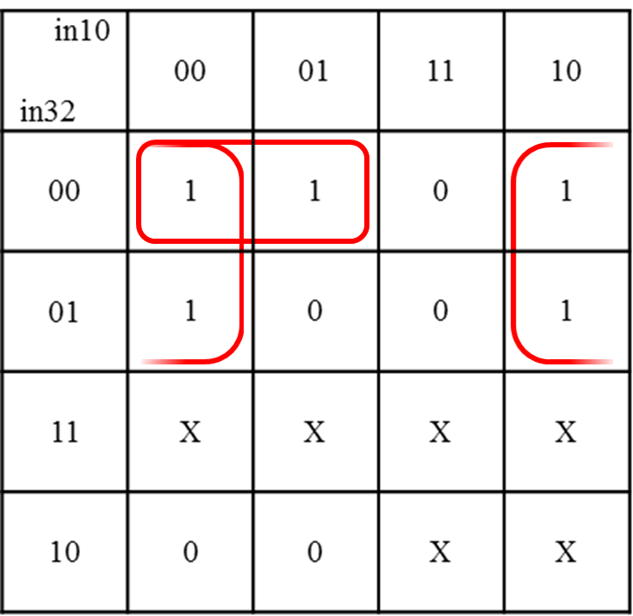

The minimized logic equation is:

f (in3, in2, in1, in0) = (~in0&~in3)|(~in1&~in2&~in3)

b-2) The implementation using a binary-select 10-to-1 multiplexer can be done as follows:

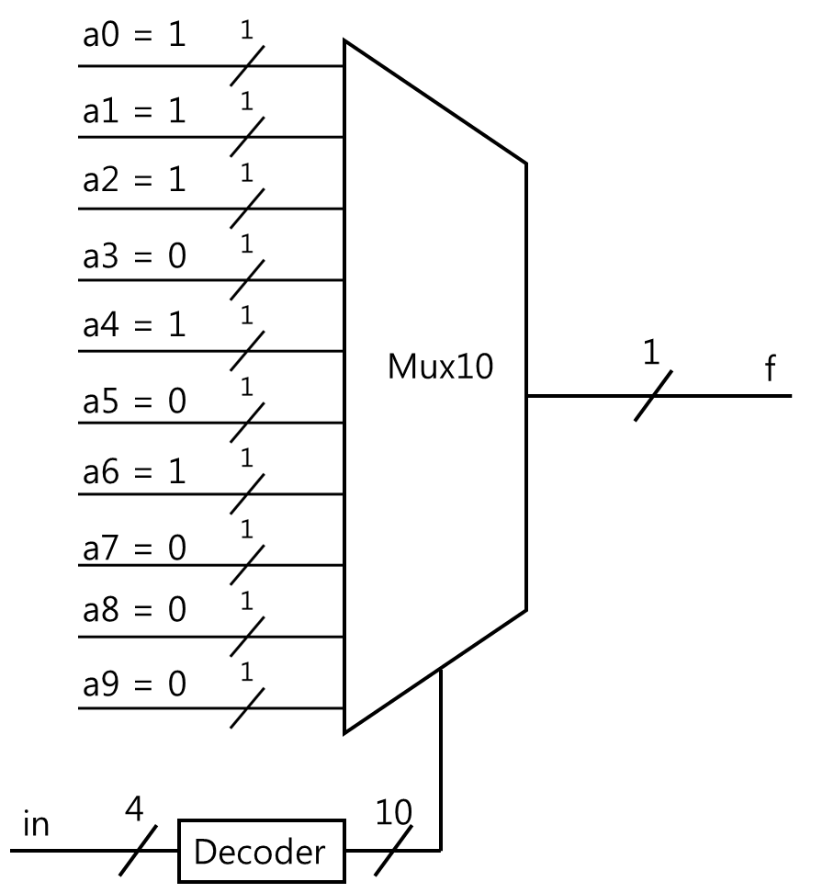

**2. Simulation of the studentID**

a. DUT (Device Under Test) modeling in Verilog (Verilog Code)

a-1) Verilog code for studentID_kmap is as follows:

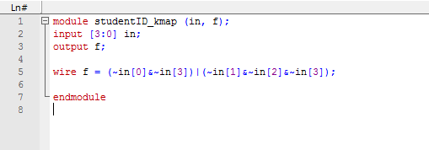

a-2) Verilog code for studentID_mux is as follows:

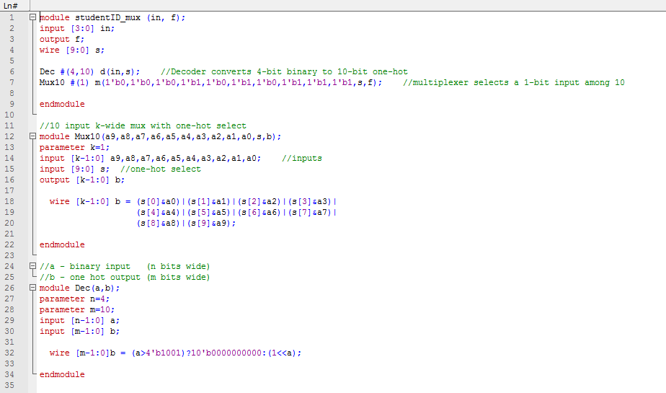

b. Testbench modeling in Verilog (Verilog Code)

b-1) Verilog code for TB_studentID_kmap is as follows:

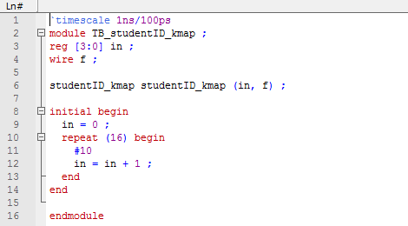

b-2) Verilog code for TB_studentID_mux is as follows:

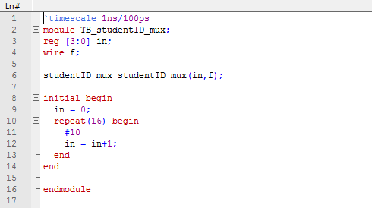

c. Simulation result in waveform

c-1) The waveform for the studentID_kmap is as follows:

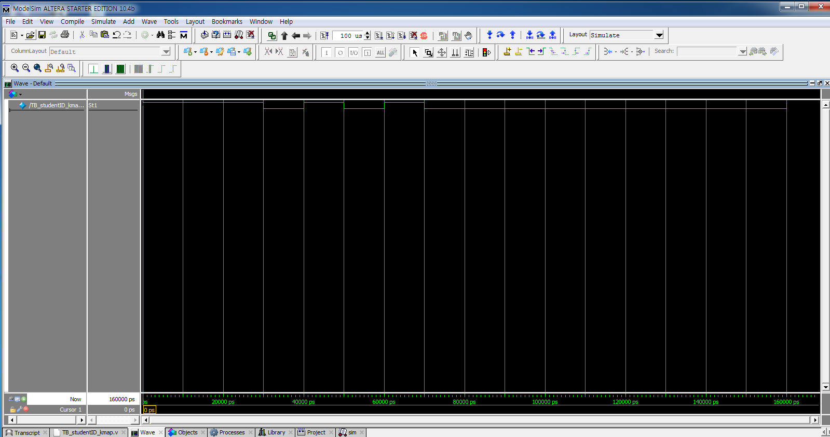

-The values of 10 outputs corresponding to 10 inputs from 0 to 9 are 1, 1, 1, 0, 1, 0, 1, 0, 0, 0. These values are exactly the same as f of the truth table.

-The values of 6 outputs corresponding to 6 inputs from 10 to 15 are all zeroes. This result is correct because the output function, f, of the DUT (studentID_kmap) produces 0 when in[3] = 1.

c-2)The waveform for the studentID_mux is as follows:

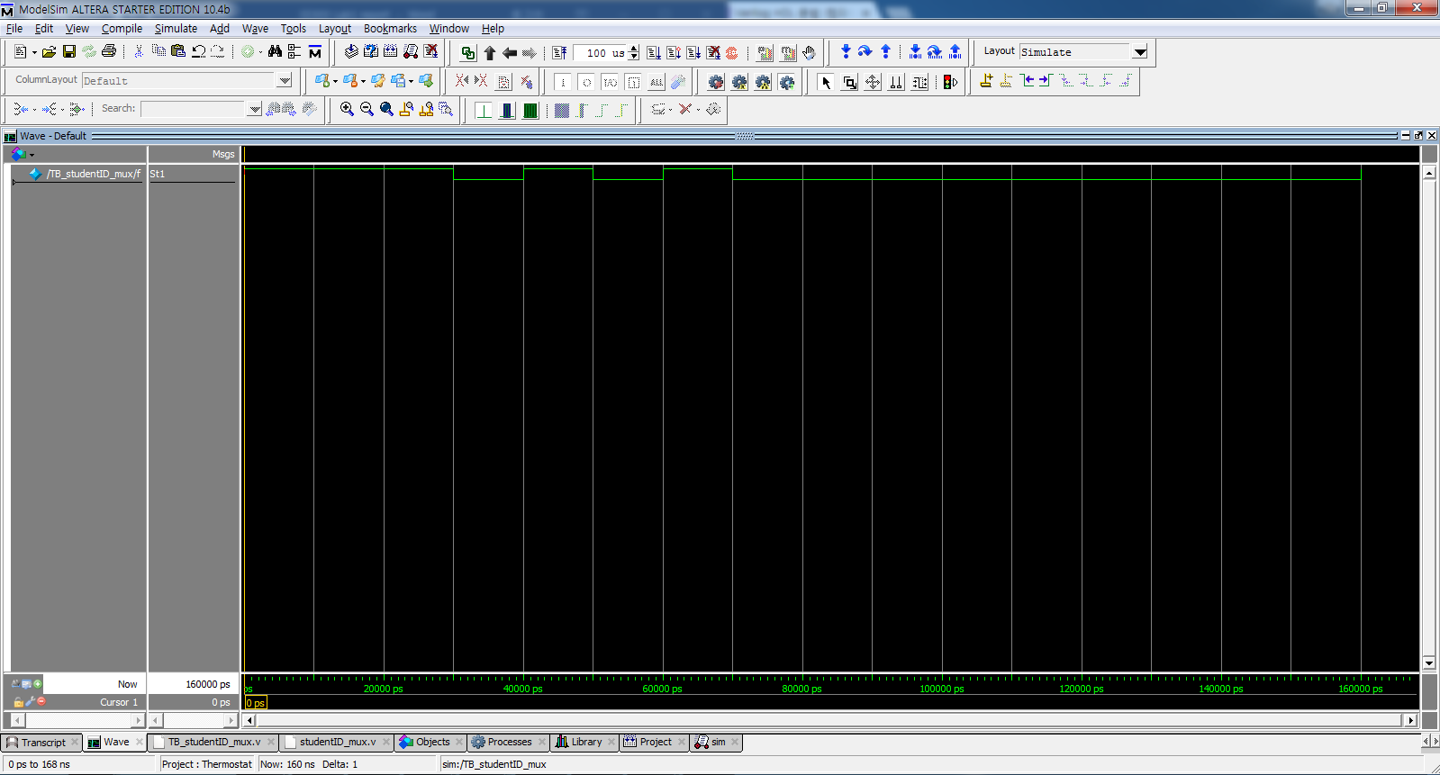

-The values of 10 outputs corresponding to 10 inputs from 0 to 9 are 1, 1, 1, 0, 1, 0, 1, 0, 0, 0. These values are exactly the same as f of the truth table.

-The values of 6 outputs corresponding to 6 inputs from 10 to 15 are all zeroes. This result is correct because the output function, f, of the DUT (studentID_kmap) produces 0 when s=0000000000. The 10-bit output of 4-to-10 decoder is all 10’b0000000000 for 6 inputs from 10 to 15.

**3. Evaluation of the experiment**

All the 16 cases of four inputs to the DUT are tested and it is verified that the DUT functions correctly at every 10ns starting from 0ns up to 160 ns compared with the true table as shown in the following table.

|  |  |  |  |  |
| --- | --- | --- | --- | --- |
| Time(ns) | in | f  (truth table) | f_kmap  (simulation) | f_mux  (simulation) |
| 0 | 0000 | 1 | 1 | 1 |
| 10 | 0001 | 1 | 1 | 1 |
| 20 | 0010 | 1 | 1 | 1 |
| 30 | 0011 | 0 | 0 | 0 |
| 40 | 0100 | 1 | 1 | 1 |
| 50 | 0101 | 0 | 0 | 0 |
| 60 | 0110 | 1 | 1 | 1 |
| 70 | 0111 | 0 | 0 | 0 |
| 80 | 1000 | 0 | 0 | 0 |
| 90 | 1001 | 0 | 0 | 0 |
| 100 | 1010 | X | 0 | 0 |
| 110 | 1011 | X | 0 | 0 |
| 120 | 1100 | X | 0 | 0 |
| 130 | 1101 | X | 0 | 0 |
| 140 | 1110 | X | 0 | 0 |
| 150 | 1111 | X | 0 | 0 |

Accordingly, the simulation is done completely.

As I discussed on 2.c, values of 6 outputs corresponding to 6 inputs from 10 to 15 are fixed as zeroes, because

-in kmap implementation : f = 0 when in[3] = 1.

(Since f (in3, in2, in1, in0) = (~in0&~in3)|(~in1&~in2&~in3)

-in mux implementation : s value was fixed to be 000000000 when a >9,

and f value corresponding to 0000000000 was 0.